DISTRICT GROUNDWATER BROCHURE
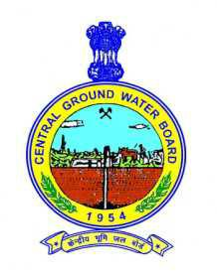

CHURU DISTRICT

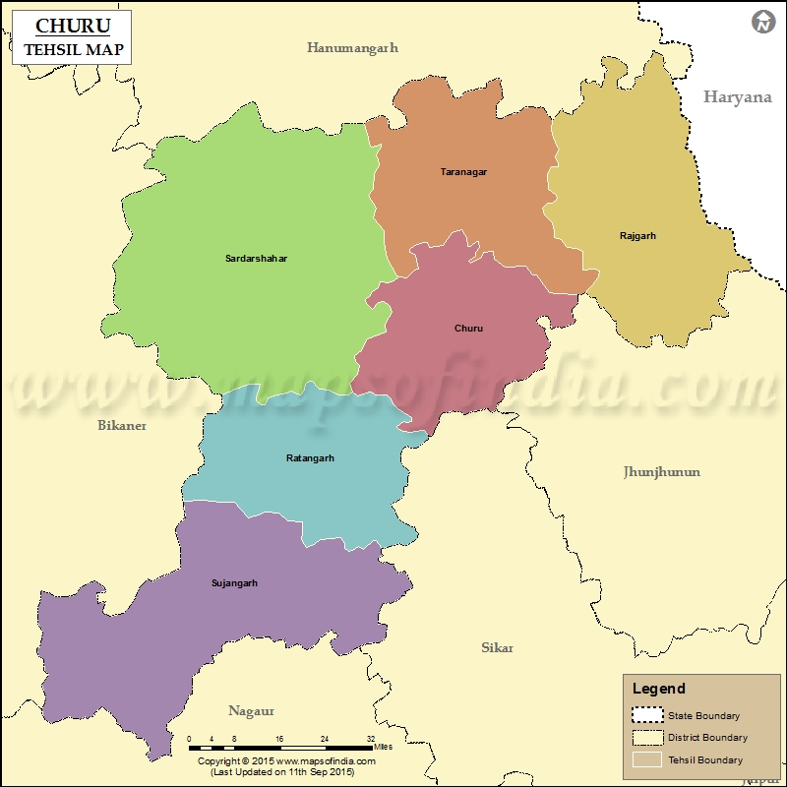

Western Region
Jaipur
2017

CHURU DISTRICT AT A GLANCE
Latitude (North) | 27º24'00" : 29º00'00"
Longitude (East) | 73º40'00":75º38'00"
Geographical area (sq. km) | 16830sq km
Per cent area of the State | 4.92
No. of Tehsils & Name | (7)  Sujangarh, Sardarshahar, Rajgarh, Churu, Ratangarh, Taranagar, Bidasar
No. of Blocks & Name | (6)  Sujangarh, Sardarshahar, Rajgarh, Churu, Ratangarh, Taranagar
No. of Villages | 899
Population (as per 2011  census) | Rural : 1463312  Urban : 576235  Total : 1156597
Average annual rainfall (mm)  (2006-2016) | 369.60mm
Major physiographical  Units | The major part of the district is covered with extensive blanket of sand, through which low lying isolated hillocks of hard nature.
Major Drainage | Kantli river
Land Use (ha) ( Source Rajasthan Agriculture Statistics 2013-14)
Forest area | 6616
Other uncultivable land excluding current fallows | 52495
Fallow land | 42711
Land not available for cultivation | 66303
Net sown area | 1153316
Total cropped area | 1354565
Area sown more than once | 201249
Principal crops ( Source Rajasthan Agriculture Statistics 2013-14)
Crop |  | Area (ha)
Wheat |  | 33368
Bajra |  | 326230
Barley |  | 7084
Gram |  | 387681
Pulses |  | 253926
Cotton |  | 320
Oil seeds |  | 32252
Irrigation by different sources (Ha) ( Source District Agriculture Statistics 2013-14)
Source |  |  | Net area irrigated | Gross area irrigated
Canals |  |  | 7334 | 7630
Tanks |  |  | 0 | 0
Tubewells |  |  | 64949 | 110768
Other wells |  |  | 34449 | 43983
Other sources |  |  | 0 | 0
Total |  |  | 106732 | 162381
No. of observation wells  Monitored |  |  | 39
Geological formations |  |  | Quaternary, Tertiary (Palana Series, Marwar supergroup)
Principal water bearing  Formations |  |  | Older Alluvium, Sandstone, Limestone, Schist, Phyllite
Pre-monsoon depth to  water level during 2017 (mbgl) |  |  | 5.66 to 66.85
Post-monsoon depth to  water level during 2017 (mbgl) |  |  | 6.66 to 64.10
Ground Water Quality
Electrical Conductivity |  |  | 265-10000 µS/cm at 25°C
Fluoride |  |  | 0.01-1.91 mg/l
Nitrate |  |  | 0.56-253.81 mg/l
Iron |  |  | 0.005- 3.63 mg/l
Type of water |  |  | Alkaline
Ground Water Exploration
Type of wells |  |  | Total
EW |  |  | 51
OW |  |  | 10
SH |  |  | 12
Depth of wells (m) |  |  | 55 to 241
Discharge (lpm) |  |  | Meagre to 1121
Total annually replenishable ground water resource |  |  | MCM
Net annual GW availability |  |  | MCM  MCM
Gross GW draft for all uses |  |  | MCM  MCM
Stage of GW development |  |  | %  %
Major ground water problems and issues |  |  | Over-exploitation of ground water, declining ground water levels

Ground Water Information
Churu District
Contents
1.0 Introduction 1
2.0 Rainfall & Climate 2
3.0 Geomorphology, Drainage, Soils, Land Use
4.0 Irrigation.......................................................................................4
5.0 Ground Water Scenario 5
6.1 Depth to water level 6
6.2 Water level fluctuation 7
6.3 Water level trend 7
7.0 Ground Water Quality 10
7.1 Quality of shallow ground water 10
7.0 Ground Water Management Strategy 14
7.1 Ground Water Development 14
7.2 Water Conservation & Artificial Recharge 14
8.0 Ground Water Resources............................................................14
9.1 Status of Ground Water Development......................................14
10.0 Ground Water Related Issues & Problems 14
11.0 Ground Water Management Strategy.........................................15
11.1 Ground Water Development........................................................16
11.2 Water Consurvation and Artificial recharge..............................16
11.0 Recommendations 16

List of Figures
- Administrative Division
- Hydrogeology
- Depth to Water Level (May 2017)
- Depth to Water Level (Nov. 2017)
- Seasonal Water Level Fluctation
- Decadal Permonsoon Water Level 2007-16
- Iso- Electrical Conductivity (May 2017)
- Iso-Fluoride (May 2017)
- Distributaries of Nitrate.
- Iso-Iron
List of Table
- Areas Irrigated by various sources
- Depth to water level during and water level fluctuation (2017)
- Ground Water Resources

GROUND WATER SCENARIO

CHURU DISTRICT, RAJASTHAN

Introduction
Churu district is located in the north eastern part of Rajasthan State and extends between north latitudes 27°24′ & 29°00′ and east longitudes 73°40′ and 75°38′ . It encompasses an area of 16830 sq. km. (forming about 4.92% of total area of the entire state) and is covered in the Survey of India degree sheet nos. 44l, 44P, 44H, 45I and 45E. It is bounded on the north by Hanumangarh, west by Bikaner district,south by Nagaur district and south west by Sikar and Jhunjhunu district and Hissar district of Haryana state.
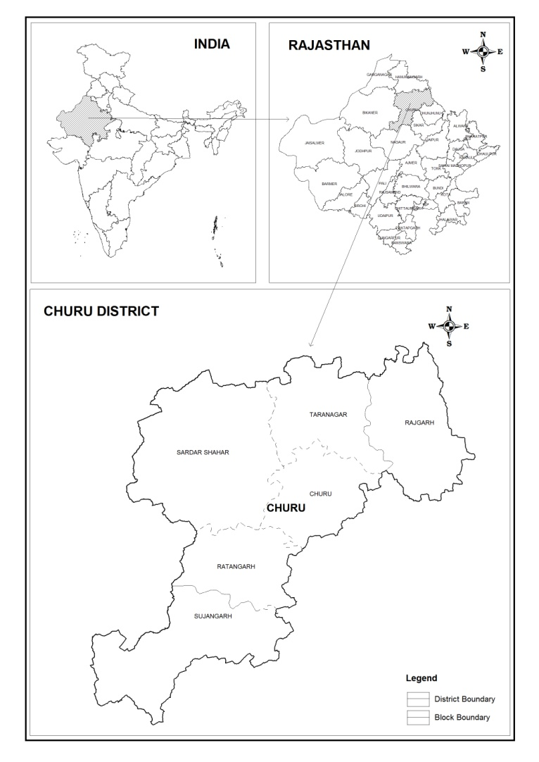
Fig. 1: Administrative divisions

Systematic hydrogeological survey was carried out by erstwhile Ground Water Division of Geological Survey of India. Central Ground Water Board
(earstwhile Exploratory Tubewells Organistaion) drilled 34 boreholes out various places in the district during the year 1965-67, under the programme construction of 250 tubewells in drought affected villages of Rajasthan. Subsequently, under United Nations Development Programme, Central Ground Water Board carried out detailed ground water investigation and exploration in the district during the year 1971-74. Recently the reappraisal hydrogeological survey was carried out by the board, covering practically entire area of the district. Further during the recent years about 23 tube wells have been constructed by the Board for water supply to drought affected villages of the district. The Central Ground Water Board has established 43 National Network Hydrogeological Stations in the district and measuring water level 5 times in a year (recently reduced to 4 times) since 1972, as a part of its programme of nationwide water level instrument.

2.0 Rainfall & Climate
Mean annual rainfall (2006-2016) of the district is 269.60 mm. Almost 95% of the total annual rainfall is received during the southwest monsoon, which enters the district in the last week of June and withdraws in the middle of September.
Climate is generally dry except during the monsoon period. Humidity is the highest in August with mean daily relative humidity of 80%.

3.0 GEOMORPHOLOGY, DRAINAGE, SOIL AND LAND USE
(a) Physiography:

Churu district is located very near to northern extension of Aravalli hills which is trending NE-SW direction and raising to a maximum height of about 500 m above mean sea level in the area adjoining to district boundary. However, the major part of the district is covered with extensive blanket of sand, through which low lying isolated hillrocks of hard rock occur. The sand dunes which are mostly of settled nature and interdunal hallows form undulating topography. The regional trend of these sand dunes are along NE-SW or NNE-SSW direction. The district has gentle slope towards north or north-west, with the highest and lowest altitude being over 500 m and less than 230 m respectively above mean sea level.

(b) Drainage:

There are no major river system in the district, except for a few short, intermittent and ephermeral channels. The largest drainage course is Kantli river which enters the district in the south-eastern side from Jhunjhunu district and disappears near Rajgarh, discharging storm runoff only in the period of high rainfall.
Recent studies of landsat imageries has revealed the extension of present course of Kantli river, north of Rajgarh, upto district border, from where it has taken westward swing. The mosaic of landsat imagery has also indic ated frequent shifting of Kantli river course from eastward to present situation which probably joined the river Saraswati course, passing from the nearby area in recent time.

(c) Soil:

The northern part of the district is covered with sand dunes while southern part is occupied by desert soils. The desert soils are usually light yellowish brown to yellowish brown, calcareous sands with little clay. Their hydraulic conductivity goes up to 13.6 cm/h, while minimum available moisture recorded was 1.1 percent. The large fine sand fraction reflects their being mainly of aeolian origin.
The other kind of soil occurring in the district are red desert soils and saline soils of the depression. The red desert soil occupy a narrow belt in southern and western part of the district (south of Sardarshahar and around Ratangarh). They are typically deep brown, non- calcareous, loamy sands and sandy loams, partially derived from sandstone and from alluvial deposit. The hydraulic conductivity of the profile examined near Fatehgarh ranged from 0.5 to 2.5 Cm/h. Minimum available moisture recorded 1.38 percent. The saline soils are found in low interdunal areas, and area of fine texture. Generally, they are saline or sodic having low permeability value and impeded drainage.

Structure:

As referred above, the longitudinal faults, running at most parallel in NNE-SSW direction and passing from Bidasar-Bandhnau and Sandwa-Kitasar-Ranasar, divides the district into two distinct geological units. The area lying east of Bandhnaw- Bidasar fault which falls under up throw side is known as Sikar basin while the western fault is known as Bikaner basin. In the eastern part of the district due to upthrowing of the fault the Pre-Cambrian crystalline basement have been uplifted, causing practically total erosion of upper horizon of Marwar Super Group (Bilwara and Nagaur group) and reduction in thickness of Palana series and Quaternary alluvium. The western part of the district which falls under the down throw side of fault have considerable thickness of Palana sediments and rock units of Marwar Super Group are preserved.

4.0 Irrigation

The principal means of irrigation in the district are wells though the small area is irrigated by tanks also. Ground water plays an important role for irrigation and is utilized through dug wells, dug cum bored wells and tube wells. The details of the net and gross irrigated area by different sources are given in Table 1.

Table 1: Area irrigated by different sources ( As per Agriculture Statistics 2012-13)

Source | Net area irrigated (ha) | Gross area irrigated (ha)
Canals | 7334 | 7630
Tanks | 0 | 0
Tubewells | 64949 | 110768
Other wells | 34449 | 43983
Other sources | 0 | 0

5.0 GROUND WATER SCENARIO

Aquifer System
Based on the nature of rock type and their porosity the aquifer system of Churu district may be sub divided broadly into following hydrogeological units:

- Unconsolidated formation
1. Ground Water in Pre-Cambrian Crystalline basement
The rocks of basement complex are mainly Granite gneisses and schist, These occur as outcrop or shallow sub outcrop around Sujangarh and central south part of the district which form poor aquifer. Ground water occurs confined conditions in weathered portion of rock unit and in joints, fractutes and other weak jines. The extent of weathering in the area is generally low and varies from 2 to 10 m in thickness. The yield of dug wells tapping thesf formations is generally poor which depends upon the extent of weathering and diameter of the well. The specific yield estimated range between 0.5 to 1.0 percent.
2. Aquifer of Bilara Limestone
The Bilara limestone overlying the basement crystalline rocks and Jodhpur sandstone, is is associated with evaporate sequence which include gypsum, anhydrite and halite crystalline beds. The formation is uplifted due to faulitig and exposed only the south western part of the district. In eastern part of the district it is totally eroded due to upthrowing of faulted strata and in western part of the district it occurs below Nagaur group of rocks / these limestone evaporates are deep seted . The ground water in faulted zone of limestone are fresh and the aquifer yield copious discharge. However in other area even hydraulic characteristics are favourable the water is too saline for most of the purposes.
3. Aquifer of Nagaur Group
The Nagaur group is composed of medium to fine grained sandstone, siltstone and forrugin shale, which often contains gypsum crystals. Thses formations is exposed in narrow belt between the major fault and basement crystalline rocksin south western part of the district. In this uplifted area these formations forms discontinuous phreatic aquifer. The thichness of saturated zone varies from few meters to about 30 meters. The transmittivity of aquifer is low ranging from 2.5 to 50 m² /day. The specific yield of the aquifer is estimated as 1%.

- Semi-consolidated formation
Palna series of Eocene age comparise fine to coarse grained well sorted sandstone, white to grey or pinkish in colour, soft and fariable. Locally it is gravelly and intercalated with clay beds. It is underlain by Nagaur sandstone and topped by quartenary alluvium. Its thickness gradually increases towards west or south west, in western part of the basin and in eastern part it appear to be totally eroded. The aquifer characteristics of Palna sandstone were were obtained by pumping test constructed under UNDP project. The saturated thickness of the aquifer ranges from 12 m to 121 m. The transmittivity ranges from 8m²/day to 1024m²/day. The sp yield of Palna sandstone has been estimated about 7%.

( C) Unconosolidated formation
Aquifer of Quartenary alluvium and Aeolian sand. The major part of the district is covered with Aeolian sand and quartenary alluvium which forms the chief source of ground water in the district. The alluvium comprises of fine to coarse grained sand, with gravel and pebbles, silt and clay with Kankar. In wester part of the district it overlies the shale and palna sandstone, while in eastern part of the district these are laid down over the eroded basement of pre Cambrian granite gneiss and Jodhpur sandstone. The ground water occurs under unconfined conditions and saturated thickness varies from few meters to 60 meters.The specific capacity of wells varies from 19 between 1.85 lpm/m and having medium to good transmittivity.

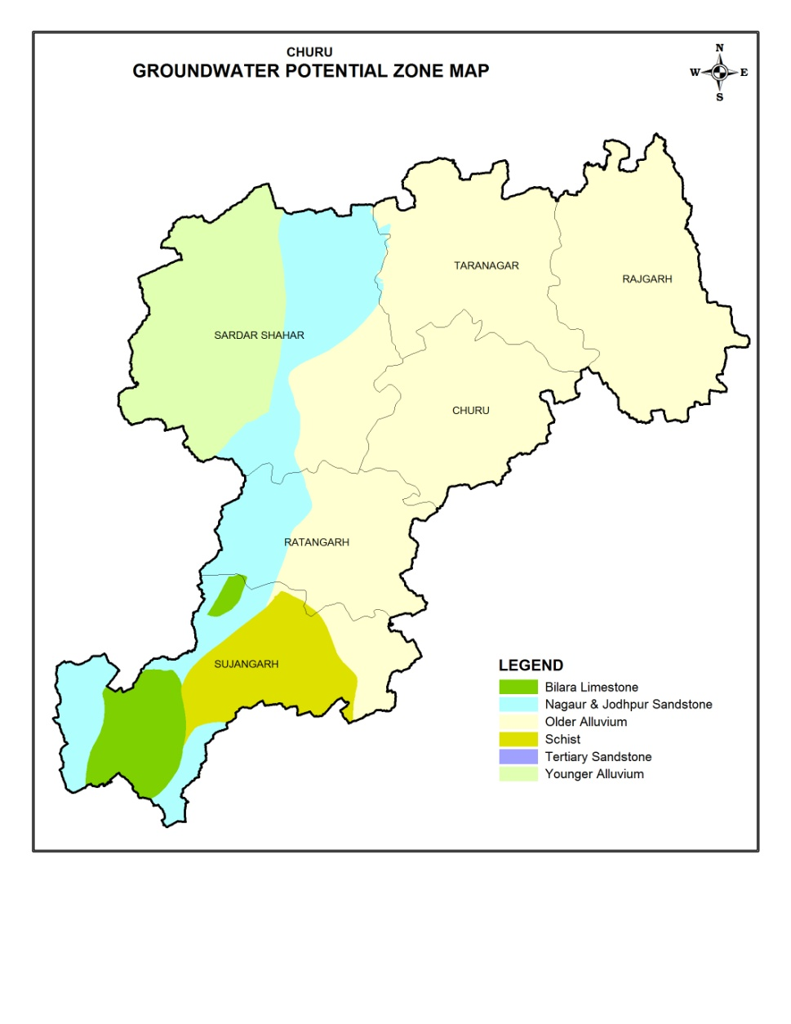
Figure 2: Hydrogeological Map

6.1 Depth to water level
In order to study the behaviour of water level, National Hydrograph Stations of CGWB and key wells inventoried during the survey have been considered. It also includes the piezometers of Ground Water Department, Rajasthan State and CGWB. Based on the data of these net work stations and inventoried wells, a regional depth to water level map has been prepared.
A perusal of depth to water level maps (Fig.3&4) shows that the water level (Pre-monsoon 2017) ranges in the area from less than 7.81m to more than 66.85m. The depth to water level in general is less than 35m in Sardarshahar,Ratangarh,Rajgarhand parts of Sujangarh block. In the northern and southern part of the district, it generally varies from 05 m to more than 20m. During post-monsoon period (November, 2017), the depth to water level varied from 6.66 mbgl to 64.10 mbgl in Sujangarh block. Depth to water level in the range of 10 to 20 mbgl has been recorded in parts of Taragarh, Rajgarh, Sujangarh, blocks. Block-wise details of depth to water level during Pre-monsoon and Post-monsoon periods and seasonal water level fluctuations are given in Table 4.

Table 2: Depth to water level during (2017)
Block | Pre Monsoon |  | Post Monsoon
 | Min | Max | Min | Max
Churu | 18.94 | 43.16 | 21.64 | 43.50
Rajgarh | 12.51 | 51.86 | 9.98 | 49.78
Ratangarh | 27.85 | 48.15 | 27.88 | 59.68
Sardarshahar | 28.76 | 66.85 | 29.11 | 60.63
Sujangarh | 5.66 | 9.10 | 6.66 | 64.10
Taranagar | 7.81 | 15.50 | 8.87 | 12.80

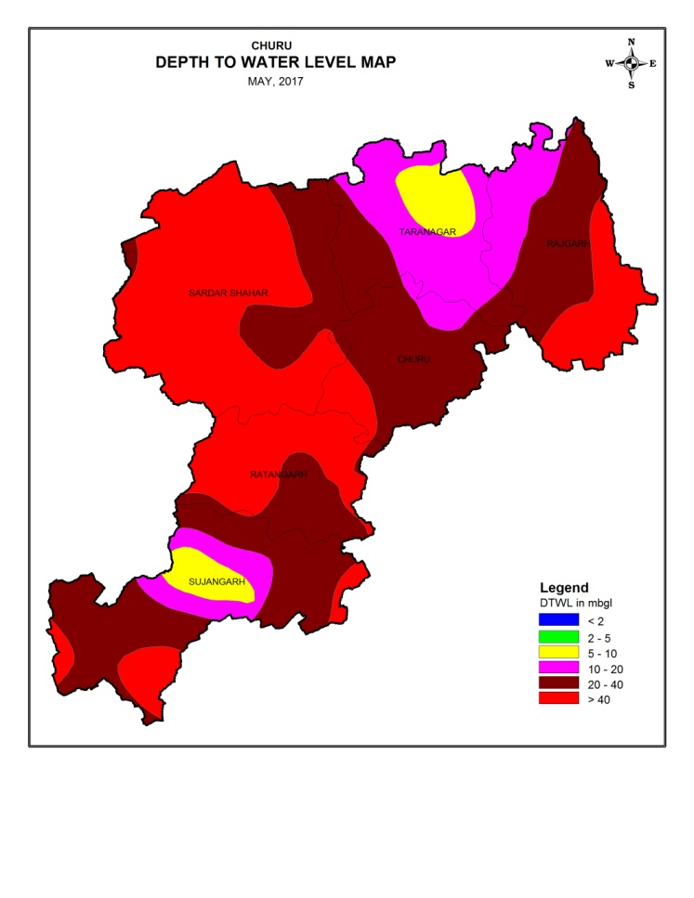

Fig 3: Depth to water level (May 2017)

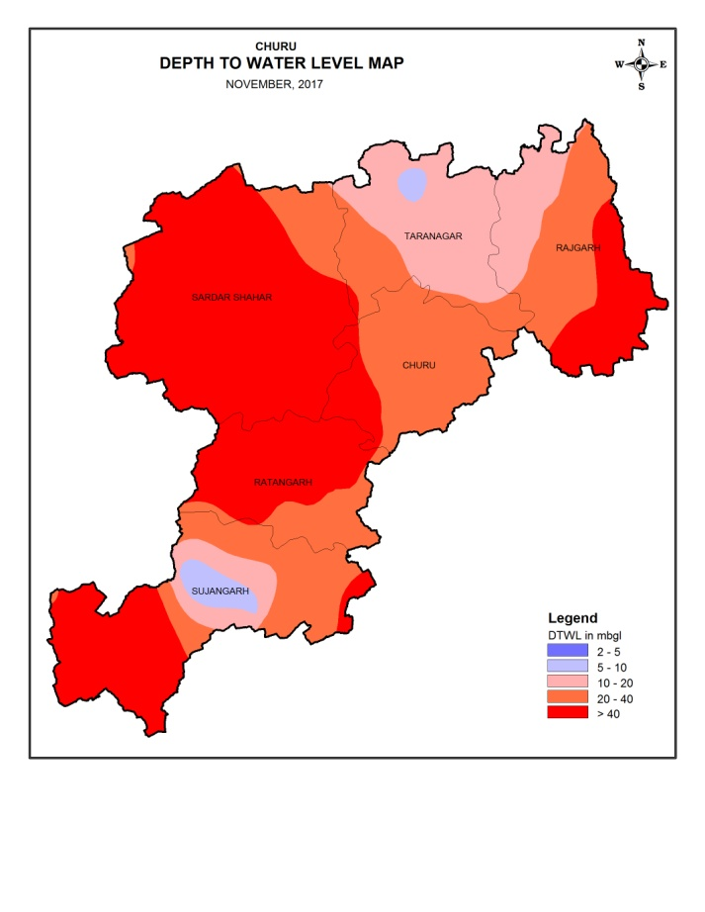
Fig 4: Depth to water level (November 2017)

6.2 Water level fluctuation
Comparison of water level data of Pre and Post-monsoon (May and November, 2017) has indicated that there has been rise of more than 4 m in water level in the most part of Rajgarh, Sardarshahar, central part of Churu, northwestern part of Ratangarh and wesr and northern part of Sujangarh.(Figure 5). Fall of upto 2 m has been observed in central and northern part of district.
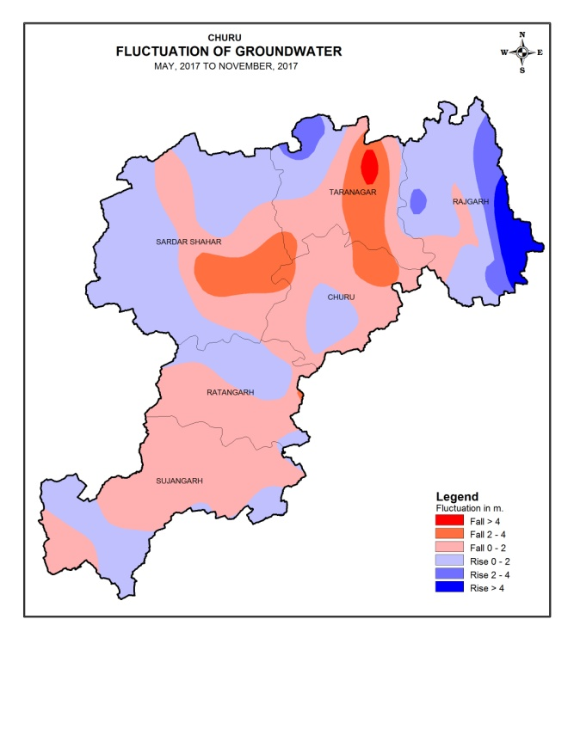
Figure 5: Seasonal water level fluctuation map (May-November, 2017)

6.3 Long term trend of water levels

Analysis of decadal pre-monsoon water level data indicates that south western and northern part of the district has witnessed rising trend in water levels of upto 25 cm/year. Declining trend of upto 25 cm/year has been recorded in major part of the (Figure 6).

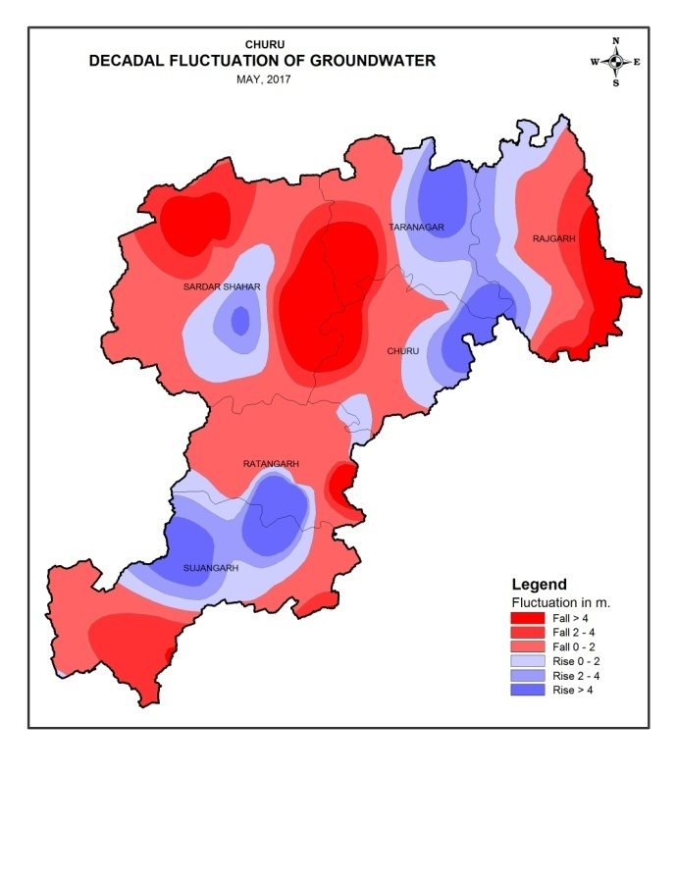
Figure 6: Decadal pre-monsoon water level trend map (May 2007 – 2016)

7.0 Ground Water Quality

Quality of shallow ground water
The quality of ground water is alkaline in major part of the district. Presence of excess fluoride, nitrate, iron and electrical conductivity in ground water has been reported from some pockets in the district.

7.1.2 pH
The pH value of ground water in the district ranges from 7.27 to 8.46 indicating alkaline nature of ground water
7.1.3 Electrical conductivity
Electrical conductivity ranges from 265 to 10000 mmhos/cm at 25⁰C. However, in greater part of the District, it varies from 750 mmhos/cm 25⁰C to 3000 mmhos/cm 25⁰C. The electrical conductivity map prepared using pre-monsoon, 2016 data is depicted in Fig.6. The perusal of map indicates that in small areas of churu, Taranagar, Sardarshahar, it is between 750 and 1500 mmhos/cm 25⁰C. More than 3000 mmhos/cm 25⁰C is noticed northern part of Sujangarh, central and north-easternpart of the district.
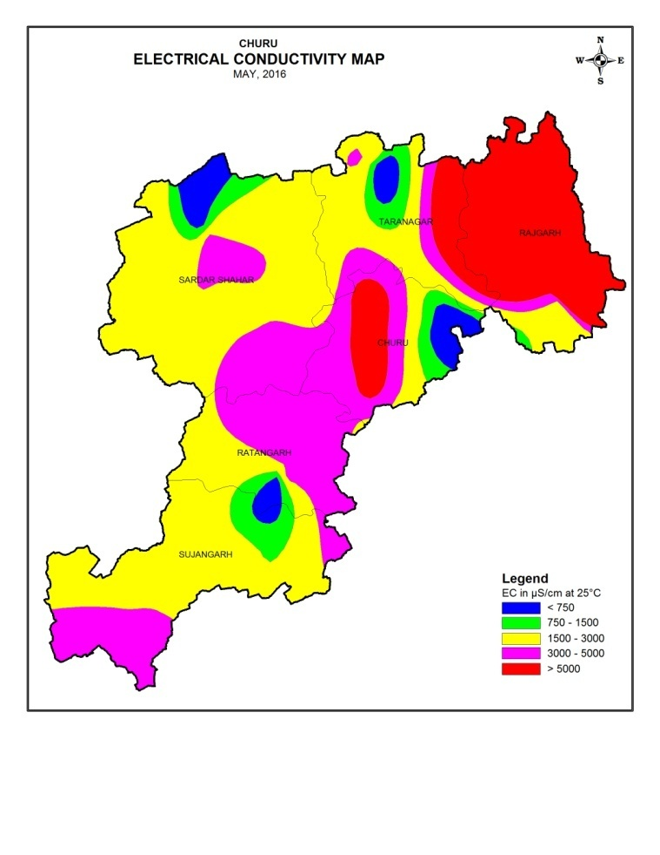
Fig. 7: Iso- Electrical Conductivity (May 2016)
7.1.4 Fluoride
Fluoride concentration in ground water ranges from 0.01 mg/l to 10.3 mg/l. Higher fluoride concentration (10.3 mg/l) has been observed at village Rajgarh. Fluoride in excess of maximum permissible limit has been observed in parts of Rajgarh,Sardarshahar, Ratangarh and Sujangarh blocks.

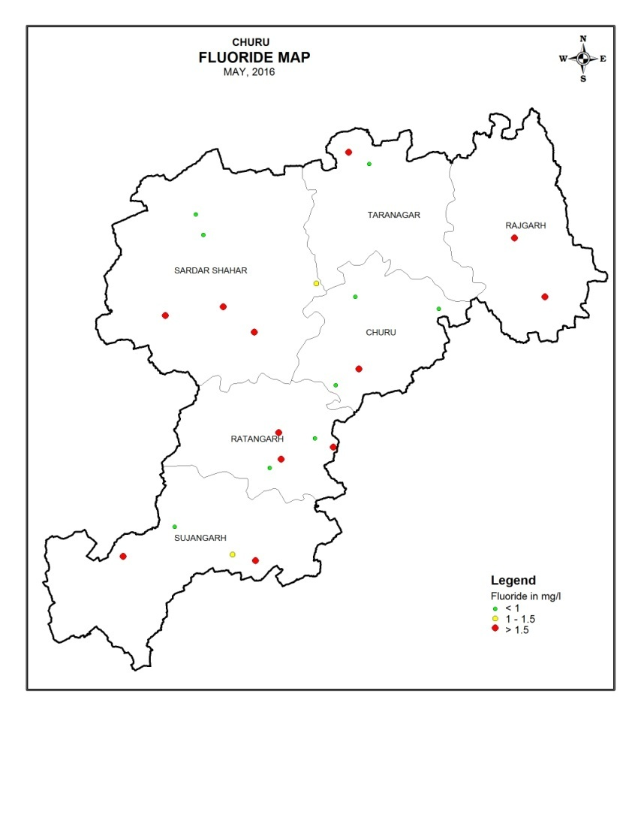
Fig. 8: Iso-Fluoride (May 2016)

7.1.5 Nitrate
Nitrate concentration in excess of maximum permissible limit of 45 mg/l has been observed in almost all blocks of the district. . Higher Nitrate concentration 1120 mg/l and 1124mg/l has been observed at village Bidasar and Dhirawas.

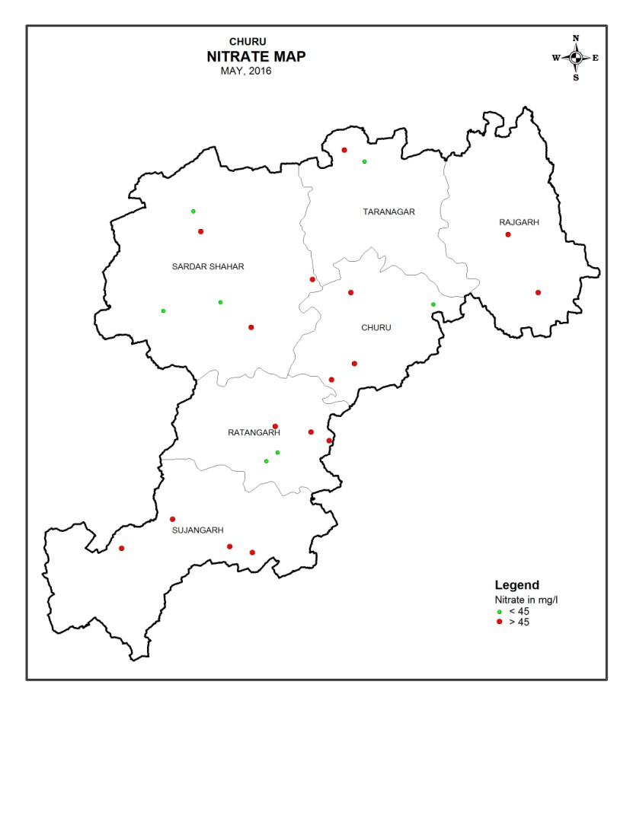
Fig. 9: Distribution of Nitrate

7.1.6 Iron
Iron concentration in major part of the district is within the maximum permissible limit of 1 mg/l. Excess iron concentration of flouride has been observed at (2.53 mg/l) Bamboo, (3.63 mg/l) Binasar, (6.93 mg/l) Sardarshahar .
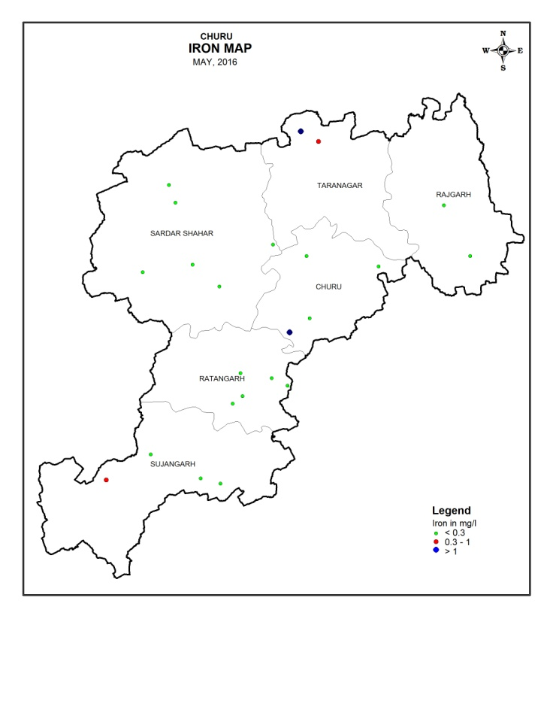
Fig. 10:Iso-Iron
8.0 Ground Water Resources

Ground water resources of the district have been estimated jointly by CGWB and State Ground Water Department as per the norms recommended by GEC’ 97. While assessing the ground water resources, saline and hilly areas have not been considered. Annually replenishable ground water resources of the district have been estimated to be 141.8221 MCM. Net annual ground water availability in the district is estimated as 134.7310 MCM. Annual ground water withdrawal for all uses is 124.7477 MCM and overall stage of ground water development is 92.59 %. Summarized block wise estimate of dynamic ground water resources is given in Table 6.

The dynamic ground water resource estimation (2013) indicates 92.59 % percentage of ground water development and all the 6 blocks are under over critical category. But during this period due to the extensive measures taken for increasing the natural recharge of ground water a no. of hydrograph stations show rising trend but still some area has shown declining trend of ground water levels in the district due to increase in the pace of ground water development. There is increase in the net irrigated areas in the district by different sources that is also reflected in the trend of water level of the district.

Table 3: Block wise replenishable ground water resources (As on 2013)

Block | Annually replenishable ground water resource  (MCM) | Net annual ground water availability  (MCM) | Annual ground water draft for irrigation  (MCM) | Annual ground water draft for domestic & industrial use  (MCM) | Gross annual ground water draft  (MCM) | Stage of ground water develop-ment  (%) | Category
Churu | 10.3453 | 9.8280 | 4.1412 | 4.5045 | 8.6457 | 87.97 | SEMICRITICAL
Rajgarh | 8.1631 | 7.7549 | 24.3456 | 4.7320 | 29.0776 | 374.96 | OVER EXPLO.
Ratangarh | 28.4327 | 27.0110 | 15.0300 | 5.0651 | 20.0951 | 74.40 | SEMICRITICAL
Sardarshahar | 59.3164 | 56.3507 | 15.8100 | 6.6138 | 22.4238 | 39.79 | SAFE
Sujangarh | 35.56452 | 33.7863 | 40.1310 | 4.3745 | 44.5055 | 131.73 | OVER EXPLO
Taranagar | 0.0000 | 0.00 | 0.00 | 0.00 | 0.00 | 0.00 | .  --
Total | 141.8221 | 134.7310 | 99.4578 | 25.2899 | 124.7477 | 92.59 | CRITICAL

9.1 Status of ground water development

Rainfall in the district is the main source of ground water recharge. Due to less rainfall and increased ground water withdrawals, ground water levels are declining in some parts of the district particularly in the northern part. Increasing urbanization and change in lifestyle have led to increased demand of water. Increasing urbanization also leads to reduced recharge. Further ground water is also an important source for irrigation in the district. The stage of ground water development for the district as a whole has reached around 92.59% as on 31.03.2013. All the blocks in the district are over-exploited. There is practically no scope left for further ground water development in the district.

10.0 Ground Water Related Issues & Problems

All the blocks in the district are over-exploited except Sardarshahar where stage of ground water development has exceeded 100 % leaving no further scope for ground water development. These blocks require judicious development of ground water. The quality of ground water is alkaline in major part of the district. Presence of excess fluoride, nitrate, iron and electrical conductivity in ground water has been reported from some pockets in the district.

11.0 Ground Water Management Strategy

Due to pressure of population and improvement in the standard of living, the demand of fresh water for both agriculture and domestic use has substantially increased. This has led to a sharp increase in ground water withdrawal. The top layer of fresh ground water is also reducing every year. Artificial recharge serves as a means for restoring the depleted ground water storage, slow down the quality deterioration and put back into operation many ground water abstraction structures.
11.1 Ground water development

Stage of ground water development in all the blocks in the district has exceeded 100%, which indicates that the scope of ground water development is already exhausted and the blocks have been categorized as “Over-exploited”. There is no scope for further development of ground water for irrigation or industrial use. However, exploratory drilling can be taken up in unexplored area for estimation of aquifer parameters. There is need to control and regulate ground water development in the entire district.

11.2 Water conservation and artificial recharge

Precious ground water resources have to be conserved for sustainable availability. There is need to reduce/ avoid wastage of water in various uses. Ground water should be used judiciously taking into account modern agriculture water management techniques by cultivating crops needing less watering and use of sprinkler system & drip irrigation should be encouraged.

It is recommended that increasing number of ground water structures should not be encouraged and artificial ground water recharge schemes like check dams, bunds, anicuts etc., should be constructed at appropriate hydrogeological locations. Surface water reservoirs like ponds/ tanks etc. should be constructed, which would serve dual purpose of supply of water during lean period and recharge to the ground water body. Also watershed development projects and soil conservation projects should be encouraged.

12.0 Recommendations
- As the stage of ground water development in the district as a whole is 92.59%, practically no scope is left for construction of new ground water abstraction structures for irrigation purposes except for drinking water supply. However, out of six blocks, only one block viz. Sardarshahar block falls under safe category where a very limited scope of future ground water development exists owing to salinity hazard.
- Artificial recharge measures like small check dams, anicuts, earthen dams; nala bunds etc. may be constructed at feasible sites to store rainwater and excess runoff from the area. This will increase the recharge to ground water body and as a result of which the yield of wells located in the vicinity will be increased.
- Watershed development and control of soil erosion activities should be encouraged in the area under different programmes.
- Surface run off can be harnessed by constructing tanks at feasible sites in the eastern part of the district for supplementing irrigation potential to increase the agricultural production.
- Modern agriculture management techniques have to be adopted for effective and optimum utilization of water resources. This can be achived by maintaining minimum hours of pumping and selecting most suitable cost effective cropping pattern with proper soil and water management.
- In areas affected with salinity hazard, salt tolerant crops should be encouraged for cultivation.
- Most parts of the district suffer from salinity problem, it is essential to precisely identify the fresh water aquifers through borehole logging to avoid failure of tubewells in saline belt. Cement sealing should also be invariably done precisely to seal off the saline aquifer.
- Over-exploitation may disturb the hydrochemical balance of fresh and saline water interface leading to contamination of saline water ingress. Therefore, proper care should be taken to avoid over-exploitation. Clustering of tube wells should also be avoided.
- There is need to educate people to make them aware of importance of ground water, better practices of water use available in domestic, irrigation and industrial sectors, present ground water scenario, need and means of water conservation, artificial recharge techniques etc.

